**The Title Lines Are Centered, and the Title is Written in Title Case with Arial 12 in Bold**

First Author1, Second Author2, Third Author3

1Department of Materials and Resources Engineering and Technology, College of Engineering, Mindanao State University-Iligan Institute of Technology, Iligan City, 9200 Philippines

ABSTRACT

*Leave one blank line after the title; the author's names and affiliations are also centered. The Author's Name font is Arial 10. The Abstract is in single-column format with Arial 10 italic. The Abstract should be limited to about 200 words.*

*The deadline for submitting the extended abstract is* ***April 30, 2025****. The editorial committee will review the full papers. Please submit your extended abstract electronically to the conference Google form link:* [*https://forms.gle/mCGyYRQM2v1T9uCh9*](https://forms.gle/mCGyYRQM2v1T9uCh9)*. Please note that the filename should be renamed “MetCon 2025_Family Name_Title of Study. Thank you in advance for your contribution to the success of this Conference. We sincerely look forward to seeing you in Puerto Princesa, Philippines!*

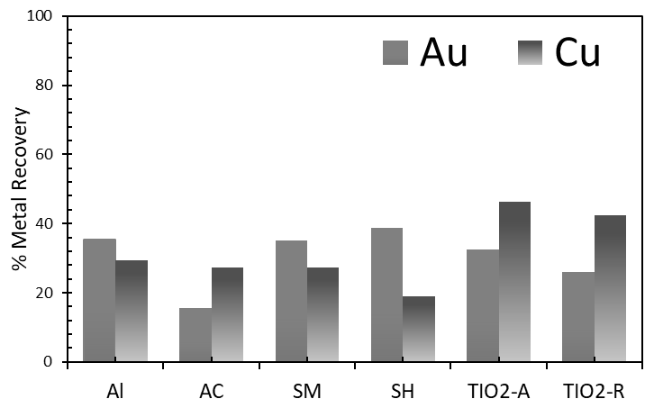

**INTRODUCTION**

The manuscript body is in a two-column format, with two characters of spacing between columns. Leave one blank line after the abstract. The first-level section titles are in Arial 10 Bold and use all capital letters. The bulk of the text is in Arial, 10-point font. The paragraphs are not indented. The text is right-justified, as shown here [1].

**OTHER SECTIONS**

Leave one extra blank line between sections and continue as shown. For the tables and figure captions, use Arial 9, as shown below.

**Subsection Example**

The second-level headings are in Upper and Lower Case, as shown in Arial 10 Bold. There is no indentation.

*Third-Level heading*

If you have to use third-level headings, use Arial 10 (Italic), as shown above.

･･････

The tables and figures should be numbered in sequence and captioned, as shown in Table 1 and Fig. 1. The following are examples of tables and figures.

**Table 1**: Table headings are also printed in Arial 9.

|  |  |  |  |  |
| --- | --- | --- | --- | --- |
|  |  | Column Heading 1 | Column Heading 2 | Column Heading 3 |
| Row Heading 1 |  | All information is in a table | is printed using | Arial 9 |
| Row Heading 2 |  | The deadline for submitting | Extended abstract | April 30, 2025 |
|  |  |  |  |  |

Fig. 1. Figure headings are also printed in Arial, 9-point font. (The layout of the figures is left to the author's discretion.)

The References should be cited in the body text in the numbering format [2]. The list of references should be placed at the end of the manuscript in chronological order.

**ACKNOWLEDGEMENTS**

Important: We would appreciate it if you could provide us with an electronic copy of your paper.

**REFERENCES**

[1] Somebody, A.J., The Manual of Style and Substance, Joe & Sons, New York (1990).

[2]…

NOTE: The extended abstract should be less than three pages, including all figures, tables, and photos. All the manuscripts will be printed in black and white.

The top and left margins are 25 mm, and the Bottom and right margins are 20 mm, respectively. The width of the space between the two columns is 8.0-8.5 mm.